# grep Assignment

**Mandatory:**

1. Use any .c file. Using grep command extract and display
   1. all lines beginning with #include with line numbers

Ans: grep -n “#include” filename

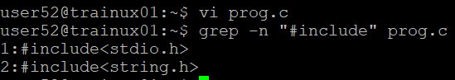

* 1. display all lines which do not begin with #include

Ans: grep -v “#include” filename

* 1. display the line number of main()

Ans: grep -n “^int main(” filename [^ symbol searches pattern from starting of the line]



grep -n “main(” filename [without ^ symbol searches patterns in t ]



* 1. extract all lines containing characters of opening and closing parathesis {(,))

Ans: grep -n “[{}()]” filename

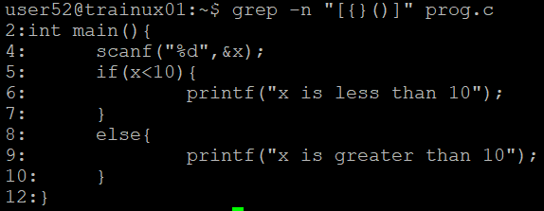

1. Perform the above operations on a set of *.c files

Ans: .grep -n “#include” *.c

grep -v “#include” *.c

grep -n “main(” *.c

grep -n “[{}()]” *.c



